MANSI UNIYAL

19EE10039

**EXPERIMENT-5**

Part A: Triggering circuit

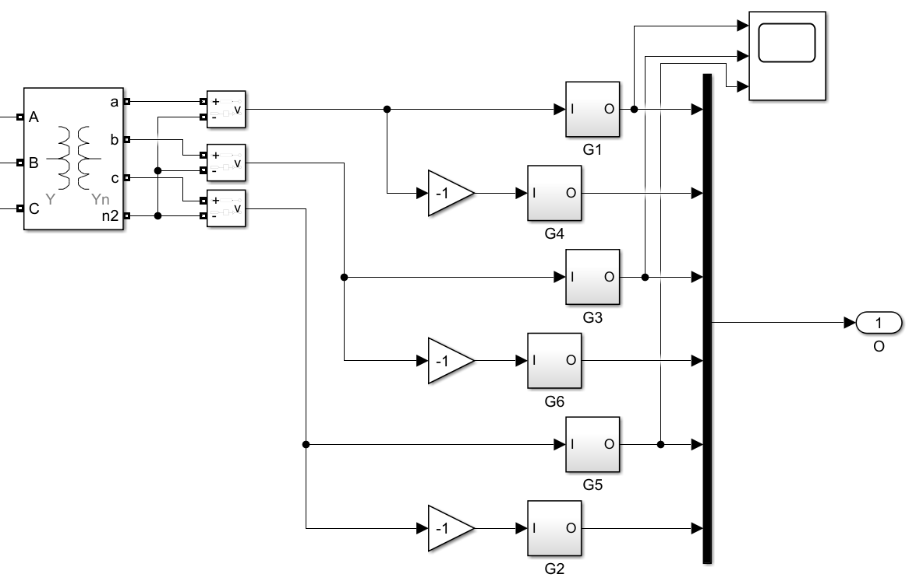

Part B: Full controlled Converter

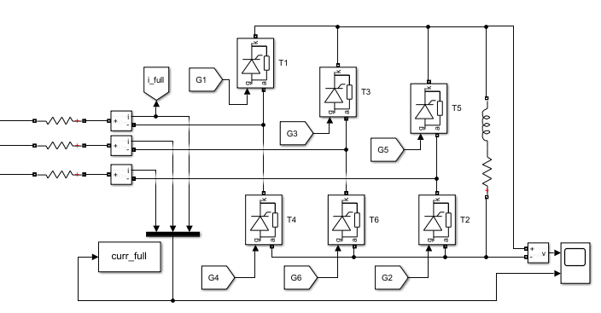

Qs1

Load resistance=44 ohm

Qs2

Avg dc o/p voltage(vDC)=220v

vLL=220v

vDC=3sqrt(2)/pi *vLL cos(alpha)

alpha=42.24 deg

Qs3

DC avg voltage=219.8v

AC 3 phase current=5.05A

Qs5

On adding source inductance

DC avg voltage=216.8v

AC 3 phase current=4.97A

Part C: Semi controlled Converter

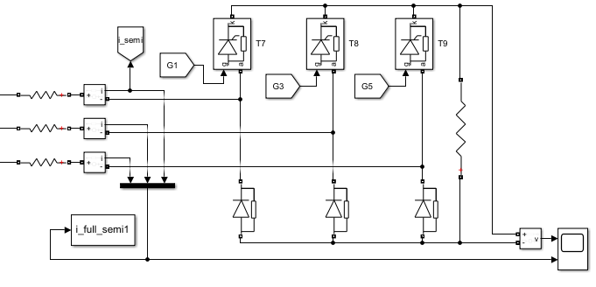

Qs1

vLL=220v

vDC=3sqrt(2)/pi *vLL (1+cos(alpha))

alpha=30 deg

vDC=277.2v

Rload=55.44 ohm

Qs3

Load voltage= 277.1v

Ac 3 phase current=5.45A

Part D:

| Parameter | Full-controlled Converter | Semi-controlled Converter |
| --- | --- | --- |
| AC side currents (RMS) | 4.08 | 4.08 |
| Fundamental component of the AC side currents (RMS) | 3.89 | 3.86 |
| THD (%) of the AC side currents | 31.13 | 34.10 |
| Input power factor | 0.922 | 0.913 |
| Fundamental active power (W) | 2025.60 | 2009.41 |
| Fundamental reactive power (VAr) | 542.7 | 538.4 |